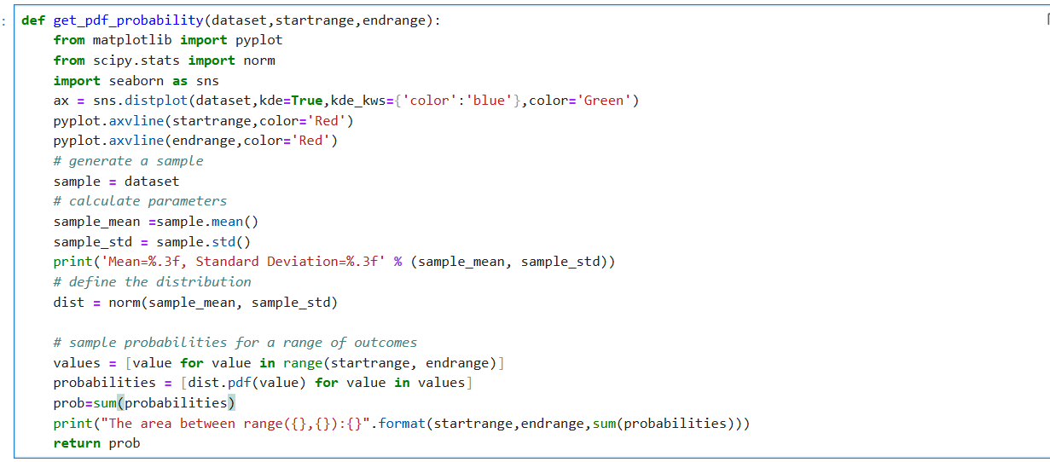



Def –> Definition

Get_pdf_probability 🡪 Function name

dataset,startrange,endrange 🡪 this variable is called as parameter, while run the command we give the values by the time it is called as arguments

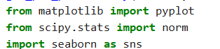

Downloading graphs

Matplotlib🡪 Python library is plotting graph by the help of pandas and numpy, it creates statistical inferences and plotting graphs of array.

Seaborn🡪 It is also python library, it is plotting graphs by the help of matplotlib and it uses beautiful theme to decorating matplotlib, pandas, and numpy.it builds on the roof of matplotlib.it helps visualizing the univariate and bivariate data.

Norm 🡪 norm function in scipy.stats is a power tool for working with the normal distribution.



Normal distribution graph is plotted by using seaborn, dataset🡪 input

Kde=true🡪 show the curve

Kde_kws🡪 which helps to show the curve line in colours.



Probability distribution color of startrange and endrange show the color line. Vertical line.

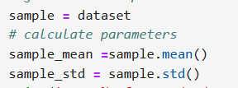

Input dataset is assigned to the variable 🡪sample.

Mean and standard deviation is assigned to the variables sample_mean and sample_std



% = indicates the start of a format specifier.

.3  = means the number will be rounded to **3 decimal places**.

f  = means the number will be formatted as a **floating-point number**.

**% (sample_mean, sample_std)**:

The % operator is used to **substitute values** into the format string.

(sample_mean, sample_std) is a tuple containing the values to be inserted into the format string:

sample_mean will replace the first %.3f.

sample_std will replace the second %.3f.



Normal distribution object is created by the specified mean and standard distribution.



It creates the list “Values” by iterating the range of numbers defined by (startrange,endrange)

Startrange 🡪 input value and Endrange🡪 input value

Given input values are one by one stored in value and the same inputs are given as the input for the variable “values”



 It calculates the probability density function  for each value in the list values using a normal distribution object.

The list of results in values will be iterating to the variable “value”,

Iterated values will be taken for normal distribution of probability density function.



The summation of the above step(probabilities) is taken as the out of the variable “prob”



It created sum of probabilities for a given range (startrange to endrange)

**STANDARD NORMAL DISTRIBUTION**

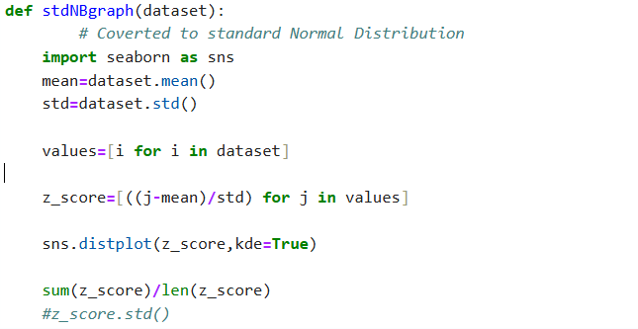

stdNBgraph – Function name

dataset 🡪 Parameter

seaborn 🡪 plot graph

mean, std 🡪 variable for mean and standard deviation



One liner for loop, which takes all the values from dataset, stored as list in i, the same list is stored in the variable “Values”



Z_Score is formula for finding standard normal distribution by mean as 0 and std as 1 and by values data are saved in “j”.



Sns is used to plot the graph.



Sun(z_score) 🡪 calculate the total sum of the elements in z_score object

Len(z_score)🡪 calculate the number of elements in z_score object